Circuit Analysis (Lab # 02)
Proteus screenshots of Experiments:
Experiment no. 01:
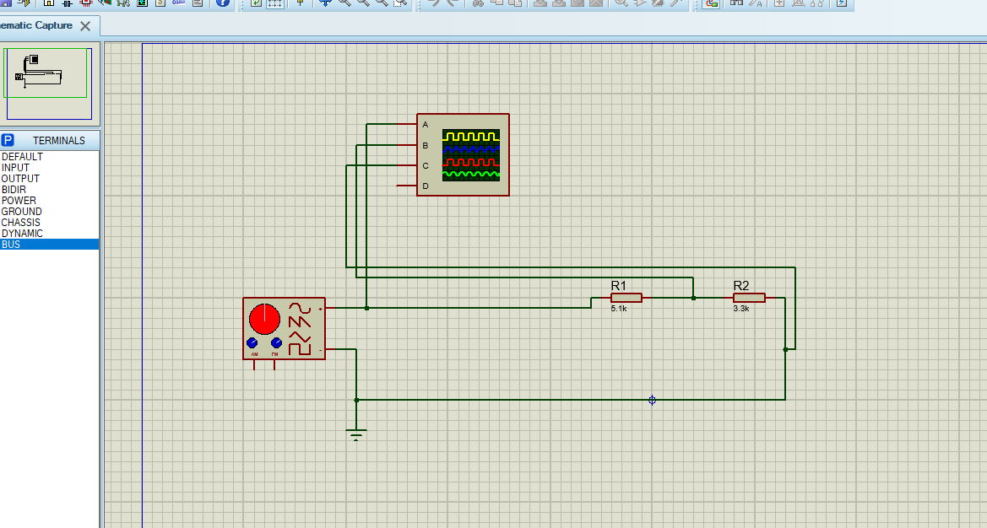
Signal generator settings:
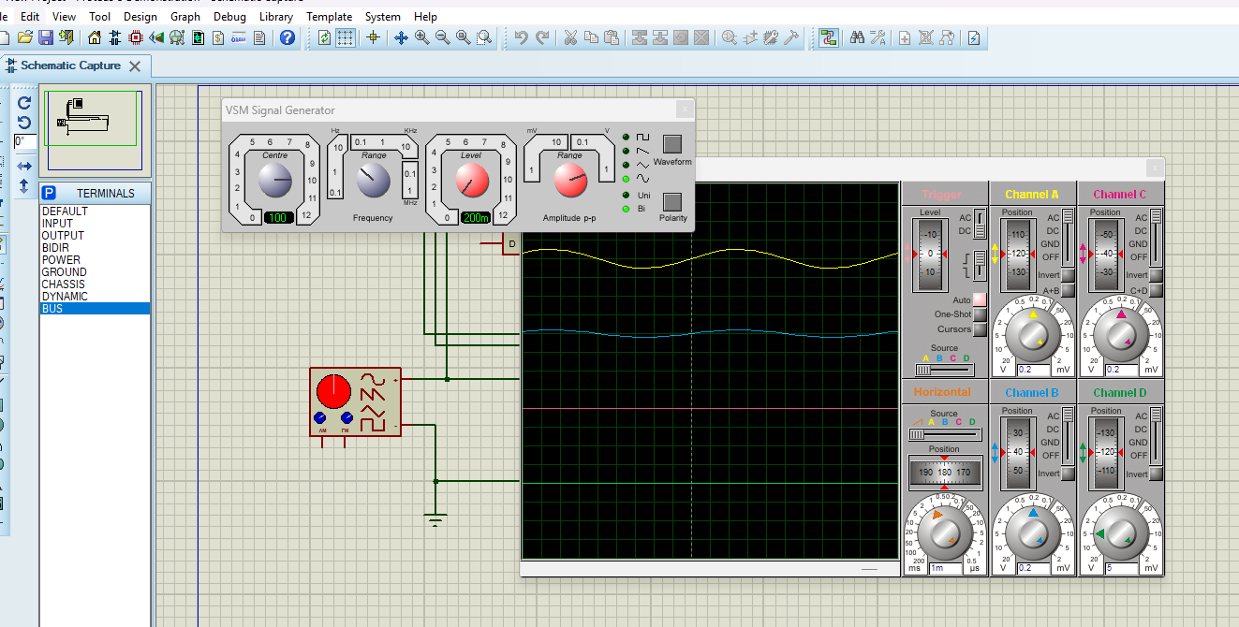

Experiment no. 02:
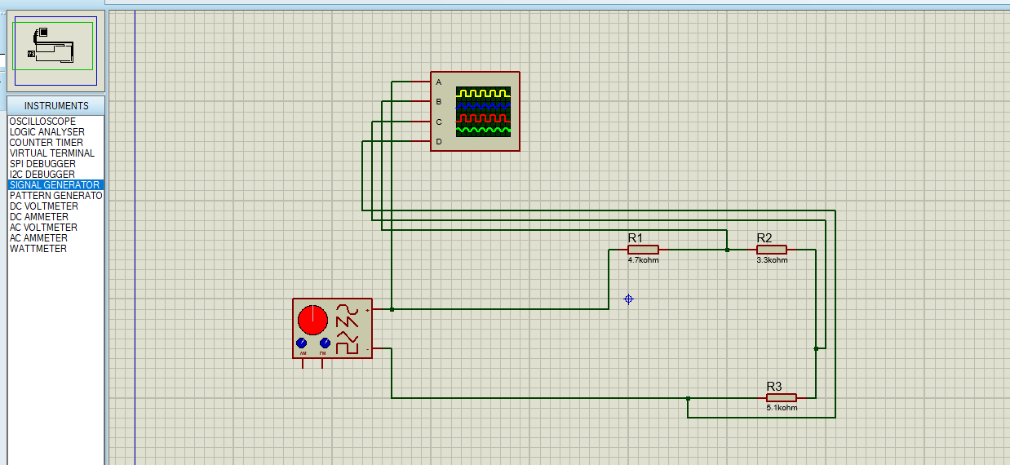
Signal Generator Settings:
